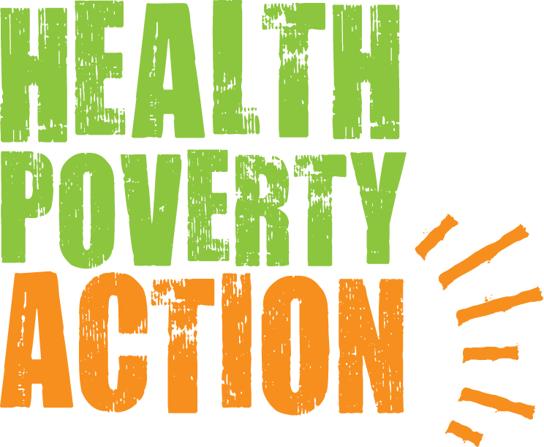

Job Title: Country Director, Lao PDR

Job purpose: Representing Health Poverty Action Staff in Laos

Responsible to: Head of Programme: Asia

Salary: £25,477-£29,805 plus housing and living allowance

Hours: Full time

Closing date: 15 July 2019

Interview dates: 22nd July 2019

Please note that due to the potentially high number of applications only shortlisted candidates will be notified.

Please send your application form to: personnel@healthpovertyaction.org

Health Poverty Action (HPA) is an international NGO (UK Registered Charity Number 290535) which has been working in Laos since 1994. Prior to 2011 we were operating under the name Health Unlimited.
We are currently seeking a Country Director for our Laos programme. This is an excellent opportunity to work in an established country programme covering nutrition, maternal and child health and mosquito-borne diseases, currently leading a team of about 40 staff. HPA is looking to consolidate its position in Laos, to strengthen and diversify its range of national projects, and to strengthen regional links with neighbouring HPA programmes in Cambodia, Vietnam and Myanmar.
The main functions of the post are:
- Overall management for ongoing projects in Laos, ensuring strong financial and general administration of projects and staff.
- Identification and development of new projects initiatives in Laos to contribute to HPA’s worldwide vision/mission, and strategic framework.
- Grant writing and fundraising for new HPA Laos projects in collaboration with HPA HQ programme staff.
- Representing HPA in Laos at national and international level events, advocating in pursuit of programmatic objectives and and building excellent relationships with central and local government departments, international organizations, other NGO’s and international, regional and local donors
- Oversight and management of HPA Laos staff in the country office and field offices, ensuring all staff are properly managed and supported to deliver their activities and objective. Supervision, mentoring and coaching of departmental managers and project leaders.

- Updating and implementing HPA Laos internal policy, rules and regulations, and ensuring all the HPA Lao staff are trained as well as engaged in an ongoing process of improving policies and procedures.

The person specifications for the post are:
Essential Experience Criteria

- Experience of working overseas at senior management level in an international context
- Experience of strategically managing and directing large scale projects including, implementation, management, monitoring and evaluation, risk assessment and mitigation and contract compliance.
- Strong people management experience with proven ability to lead, coach and manage a multidisciplinary and multicultural team, both in proximity and remotely.
- Proven expertise in programme design and development, networking and contract negotiations
- Experience of managing finance, administrative and human resource systems to ensure project efficiency and rigorous compliance.

Essential Skills and Knowledge

- Strong financial management skills and effective oversight of budgets
- Excellent communication and interpersonal skills, with the ability to establish effective working relationships at all levels internally and externally
- Strong writing skills strategy, proposals, business plans, budgets and reports
- Knowledge and understanding of relevant institutional donors
- Strong representation, communication and negotiation skills
- Excellent organisational skills with the ability to coordinate multiple activities

Essential Aptitude
- Positive and proactive with a solution-focussed approach to work
Ability to meet deadlines and work calmly under pressure
Ability to represent and promote HPA at the highest level
- Commitment to HPA’s strategic direction and core values
- Ability to travel extensively within the country of operation
- Ability to undertake international travel within the region and further afield as necessary.

Qualifications
- Advanced university degree in relevant field

Desirable

- Keen awareness and understanding of modern trends in humanitarian and development approaches.
- Knowledge of Lao, Thai or Lao-ethnic minority languages.

At Health Poverty Action we celebrate diversity and promote equality and inclusion amongst all of our staff and everyone we work with.

Health Poverty Action recognises that all adults and children have equal rights to protection from abuse and exploitation. Health Poverty Action condemns exploitation and inappropriate behaviour, and is committed to taking action for the protection of programme participants. In cases where positions include a high level of safeguarding risk, police checks or local equivalents will be carried out.

